7/30/2019

Bocheng Yin

Ewald Lab

University of Virginia

We run the python codes in python 3.7 & Spyder 3.3.3.

[A] Tile code: “tileScanConvexHullz_split.py”

1. The purpose of the code is to generate the coordinates of tiles within a shape on the surface. The coordinates of tiles can be used the ZEN black to command the microscope.

1. The parameters must be specified before running the code
   1. Line 11: must enter the directory where the position files will be stored. Typically, 4 ~ 5 file will be generated.
   2. Line 12: Enter the boundary positions of an area in the format of ZEN black file, “.pos”.

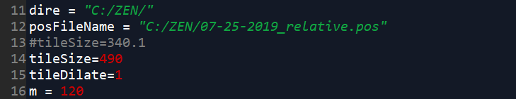

* 1. Line 14: the tile size is in the unit of micrometer. The number should NOT be smaller than the image size, 340.1 μm, which is contingent on the microscope setup (I use 25x lens on Zeiss LSM 880). By changing the tile size, the number of tiles can be controlled below 500 cross a surface.
  2. Line 16: m is the maximum number of tile position will be split into a position file.
  3. Files, “tilePos-1.pos”, “tilePos-2.pos”, “tilePos-3.pos”,… will be created.

[B] sentinel code: checkFreezingCode.py

The purpose of the code is to monitor the status of the sikulix codes, “stp_call_oneChannel.sikuli” and “stp_beCalled_oneChannel.sikuli” which automates the STOMP task. It will send a warning message once the sikulix codes have frozen for more than 30 min.